**SMART PARKING**

INTRODUCTION:

With growing popularity of Smart Cities, there is always a demand for smart solutions for every domain. The IoT has enabled the possibility of Smart Cities with it’s over the internet control feature. A person can control the devices installed in his home or office from anywhere in the world by just using a smartphone or any internet connected devices.

There are multiple domains in a smart city and Smart Parking is one of the popular domain in the Smart City. The smart parking involves finding innovative solution to optimize parking space and minimize the traffic congestion in urban areas then enchance the overall parking experience both drivers and parking operators. This technology aims to make parking easier,more efficient and environment friendly.

Furthermore, smart parking aligns with broader urban development goals by enhancing safety, promoting sustainable transportation alternatives, and integrating with other aspects of urban infrastructure, such as public transportation and city planning.

PROJECT OBJECTIVES:

Reduce Traffic Congestion: By guiding drivers to available parking spaces and reducing the time spent circling for a spot, smart parking systems aim to alleviate traffic congestion in urban areas. This can lead to reduced emissions.

Enhance Safety and Security: smart parking solutions can incorporate security features like surveillance cameras and emergency call buttons to enhance the safety of parking facilities.

Optimize Parking Space Utilization: The primary goal of smart parking is to maximize the use of available parking spaces. This involves reducing congestion and minimizing the time and fuel wasted by drivers searching for parking spots

Enhance User Convenience: Smart parking systems should make it easier for drivers to find, reserve, and pay for parking. Mobile apps, online booking, and real-time availability updates contribute to a more convenient and user-friendly experience.

Integration with Urban Infrastructure: Smart parking systems should be integrated with broader urban infrastructure, including traffic management, public transportation, and city planning, to ensure a cohesive and well-coordinated approach to urban mobility.

Scalability and Adaptability: The system should be designed to adapt to changing urban needs and to be scalable as the city or area grows.

COMPONENTS REQUIERED:

* ESP8266 NodeMCU
* Ultrasonic Sensor
* DC Servo Motor
* IR Sensors
* 16x2 i2c LCD Display
* Jumpers

WORKING:

**smart parking solution** will be built which will use an **ultrasonic sensor to detect vehicle presence and trigger the gate to open or close automatically**. The ESP8266 NodeMCU will be used here as the main controller to control all the peripherals attached to it.

It involves two IR sensor, two servo motors, one ultrasonic sensor and one 16x2 LCD.  the ESP8266 will control the complete process and also send the parking availability information to Google Firebase so that it can be monitored from anywhere in the world over the internet.**Two IR sensors** are used at entry and exit gate to detect the presence of car and automatically open or close the gate.

IR Sensor is used to detect any object by sending and receiving the IR rays. **Two servos** will act as entry and exit gate and they rotate to open or close the gate. Finally **an**[Ultrasonic sensor](https://circuitdigest.com/tags/ultrasonic-sensor) is used to detect if the parking slot is available or occupied and send the data to ESP826.

**HARDWARE SETUP:**

**1.connect the ultrasonic sensor to the ESP8266 as described in previous response.**

**2.connect the LCD display to the ESP8266 using the 12c interface.make sure you have the correct 12c address for your specific display.**

CIRCUIT DIAGRAM:

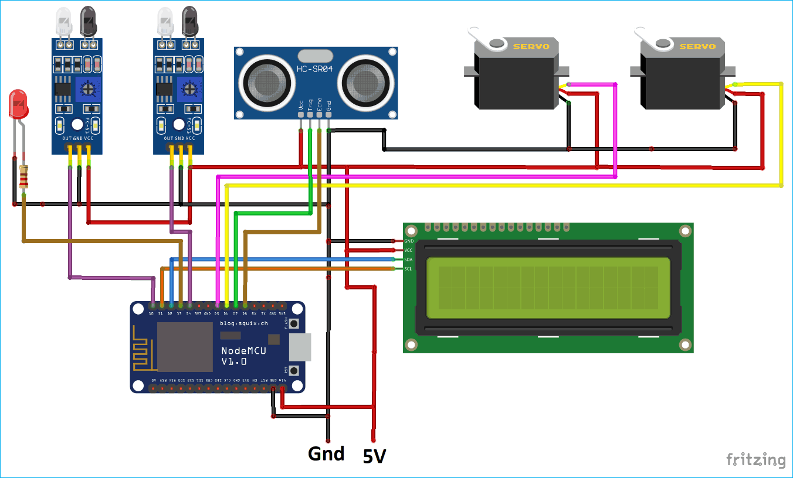

MODEL FOR SMART PARKING:

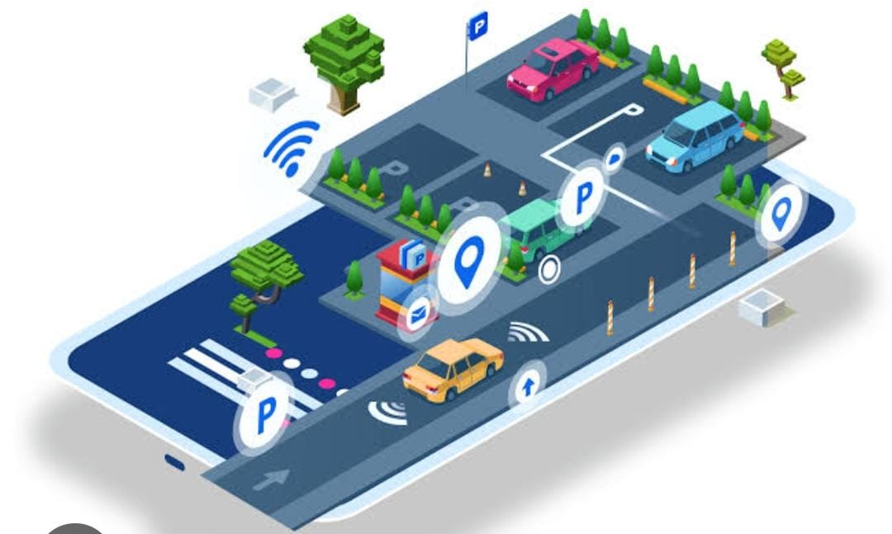

CODE AND EXPLAINATION:

For programming NodeMCU, just plug the NodeMCU to Computer with a Micro USB Cable and open Arduino IDE. The libraries are required for I2C Display and Servo Motor.

The LCD will display the availability of Parking Spaces and the [Servo motors](https://circuitdigest.com/article/servo-motor-basics) will be used to open and close the Entry and Exit gates. The Wire.h library will be used to interface LCD in i2c protocol.

The Pins for I2C in the ESP8266 NodeMCU are D1 (SCL) and D2 (SDA). The database here used will be Firebase so here we are also including the library (FirebaseArduino.h) for the same.

**#include <ESP8266WiFi.h>**

**#include <Servo.h>**

**#include <LiquidCrystal_I2C.h>**

**#include <Wire.h>**

**#include <FirebaseArduino.h>**

Then include the firebase credentials got from Google Firebase. These will include the Host name containing your project name and a secret key.

To find these values follow this

**" #define FIREBASE_HOST "smart-parking-7f5b6.firebaseio.com"**

**#define FIREBASE_AUTH "suAkUQ4wXRPW7nA0zJQVsx3H2LmeBDPGmfTMBHCT**

Include the Wi-Fi Credentials such as WiFi SSID and Password.

**#define WIFI_SSID "Smart Parking"**

**#define WIFI_PASSWORD "smartparking123"**

Initialise I2C LCD with device address (Here it is 0x27) and type of LCD.

Also include the Servo Motors for entry and exit gate.

**LiquidCrystal_I2C lcd(0x27, 16, 2);**

**Servo myservo;**

**Servo myservo1;**

Start the I2C communication for I2C LCD.

**Wire.begin(D2, D1);**

Connect the Entry and Exit Servo Motor to the D5, D6 Pins of the NodeMCU.

**myservo.attach(D6);**

**myservos.attach(D5);**

Select the Trigger Pin of Ultrasonic sensor as Output and Echo Pin as Input. The ultrasonic sensor will be used to detect the parking spot availability.

If Car has occupied the space then it will glow else it will not glow.

**pinMode(TRIG, OUTPUT);**

**pinMode(ECHO, INPUT);**

The two pins D0 and D4 of the NodeMCU are used to take the IR sensor reading.

The IR sensor will act as Entry and Exit gate sensor. This will detect car presence.

**pinMode(carExited, INPUT);**

**pinMode(carEnter, INPUT);**

Connect to WiFi and wait for some time till it gets connected.

**WiFi.begin(WIFI_SSID, WIFI_PASSWORD);**

**Serial.print("Connecting to ");**

**Serial.print(WIFI_SSID);**

**while (WiFi.status() != WL_CONNECTED) {**

**Serial.print(".");**

**delay(500);**

**}**

Begin connection with Firebase with Host and Secret Key as credentials.

**Firebase.begin(FIREBASE_HOST, FIREBASE_AUTH);**

Begin i2c 16x2 LCD and set cursor position at 0th row 0th column.

**lcd.begin();**

**lcd.setCursor(0, 0);**

Take the Distance from Ultrasonic sensor. This will be used to detect the vehicle presence in the particular spot. First send the 2 microsecondpulse and then read the received pulse. Then convert it to the ‘cm’.

**digitalWrite(TRIG, LOW);**

**delayMicroseconds(2);**

**digitalWrite(TRIG, HIGH);**

**delayMicroseconds(10);**

**digitalWrite(TRIG, LOW);**

**duration = pulseIn(ECHO, HIGH);**

**distance = (duration / 2) / 29.1;**

Digitally read the IR sensor pin as entry sensor and check if it is high.

If it is high then increment entry count and print it to [16x2 LCD display](https://circuitdigest.com/article/16x2-lcd-display-module-pinout-datasheet) and also to serial monitor.

**int carEntry = digitalRead(carEnter);**

**if (carEntry == HIGH) {**

**countYes++;**

**Serial.print("Car Entered = " ); Serial.println(countYes );**

**lcd.setCursor(0, 1);**

**lcd.print("Car Entered");**

Also move the servo motor angle to open entry gate.

Change the angle according your use case.

**for (pos = 140; pos >= 45; pos -= 1) {**

**myservos.write(pos);**

**delay(5);**

**}**

**delay(2000);**

**for (pos = 45; pos <= 140; pos += 1) {**

**// in steps of 1 degree**

**myservos.write(pos);**

**delay(5);**

**}**

And send the reading to firebase by using pushStringfunction of Firebase library.

**Firebase.pushString("/Parking Status/", fireAvailable );**

Do similar steps as above for Exit IR sensor and Exit servo motor.

**int carExit = digitalRead(carExited);**

**if (carExit == HIGH) {**

**countYes--;**

**Serial.print("Car Exited = " ); Serial.println(countYes);**

**lcd.setCursor(0, 1);**

**lcd.print("Car Exited");**

**for (pos1 = 140; pos1 >= 45; pos1 -= 1) {**

**myservo.write(pos1);**

**delay(5);**

**}**

**delay(2000);**

**for (pos1 = 45; pos1 <= 140; pos1 += 1) {**

**// in steps of 1 degree**

**myservo.write(pos1);**

**delay(5);**

**}**

**Firebase.pushString("/Parking Status/", fireAvailable );**

**lcd.clear();**

**}**

Check if the car has come to the parking spot and if it has arrived then glow led giving the signal that the spot is full.

**if (distance < 6) {**

**Serial.println("Occupied ");**

**digitalWrite(led, HIGH);**

**}**

**Else show that the spot is available.**

**if (distance > 6) {**

**Serial.println("Available ");**

**digitalWrite(led, LOW);**

**}**

Calculate the total empty space inside the parking lot and save it in the string to send the data to firebase.

**Empty = allSpace - countYes;**

**Available = String("Available= ") + String(Empty) + String("/") + String(allSpace);**

**fireAvailable = String("Available=") + String(Empty) + String("/") + String(allSpace);**

**Also print the data to the i2C LCD.**

**lcd.setCursor(0, 0);**

**lcd.print(Available);**

Alternate Python code**:**

**import machine**

**import time**

**from machine import Pin, I2C**

**from esp8266_i2c_lcd import I2cLcd**

**# Define GPIO pins for the ultrasonic sensor**

**trigger = Pin(5, Pin.OUT)**

**echo = Pin(4, Pin.IN)**

**# Define GPIO pins for the I2C communication**

**i2c = I2C(-1, scl=Pin(14), sda=Pin(2), freq=400000)**

**# Initialize the LCD display**

**lcd = I2cLcd(i2c, 0x3F, 2, 16)**

**def measure_distance():**

**# Trigger the ultrasonic sensor**

**trigger.on()**

**time.sleep_us(10)**

**trigger.off()**

**# Measure the time for the echo to return**

**pulse_time = machine.time_pulse_us(echo, 1, 30000)**

**# Calculate the distance based on the time**

**distance = (pulse_time / 2) / 29.1 # 29.1 microseconds per centimeter**

**return distance**

**while True:**

**distance = measure_distance()**

**if distance < 10: # Adjust this threshold for your specific setup**

**status = "Occupied"**

**else:**

**status = "Vacant"**

**# Display status on the LCD**

**lcd.clear()**

**lcd.putstr("Parking Spot:")**

**lcd.move_to(0, 1)**

**lcd.putstr(status)**

**time.sleep(1)**

WEB DEVELOPMENT**:**

In this script,we use Kivy to create a basic app with two buttons: one for reserving a parking spot and another for making a payment. When the buttons are clicked, they trigger the `reserve_spot` and `make_payment` functions. It should extend these functions to perform the actual reservation and payment processing using API requests to the server.

For a complete app, that would need to design more advanced UI components, implement user authentication, handle responses from the server, and manage the app's navigation flow.

Additionally, for a production-ready app, that might want to consider using a dedicated cross-platform mobile app development framework like React Native, Flutter, or others, as they offer a more robust and scalable approach to mobile app development.

from kivy.app import App

from kivy.uix.boxlayout

import BoxLayout from kivy.uix.label

Import Label from kivy.uix.button import Button

class SmartParkingApp(App):

def build(self):

layout = BoxLayout(orientation='vertical')

# Create labels and buttons for different functionalities

label1 = Label(text="Welcome to Smart Parking")

label2 = Label(text="Available Parking Spots: 10")

reserve_button = Button(text="Reserve a Spot")

payment_button = Button(text="Make a Payment"

# Bind functions to buttons

reserve_button.bind(on_release=self.reserve_spot) payment_button.bind(on_release=self.make_payment)

layout.add_widget(label1)

layout.add_widget(label2)

layout.add_widget(reserve_button)

layout.add_widget(payment_button)

return layout

def reserve_spot(self, instance):

# Implement reservation logic here

print("Reserving a parking spot...")

def make_payment(self, instance):

# Implement payment logic here

print("Making a payment...")

if __name__ == '__main__':

SmartParkingApp().run()

CONCLUSION:

Thus the way to develop mobile app program for smart parking.It include real-time monitoring,user-friendly interfaces,sensors for data collection.

This detailed project plan provides a roadmap for the development, implementation, and management of a smart parking system. It serves as a comprehensive guide for all stakeholders involved in the project